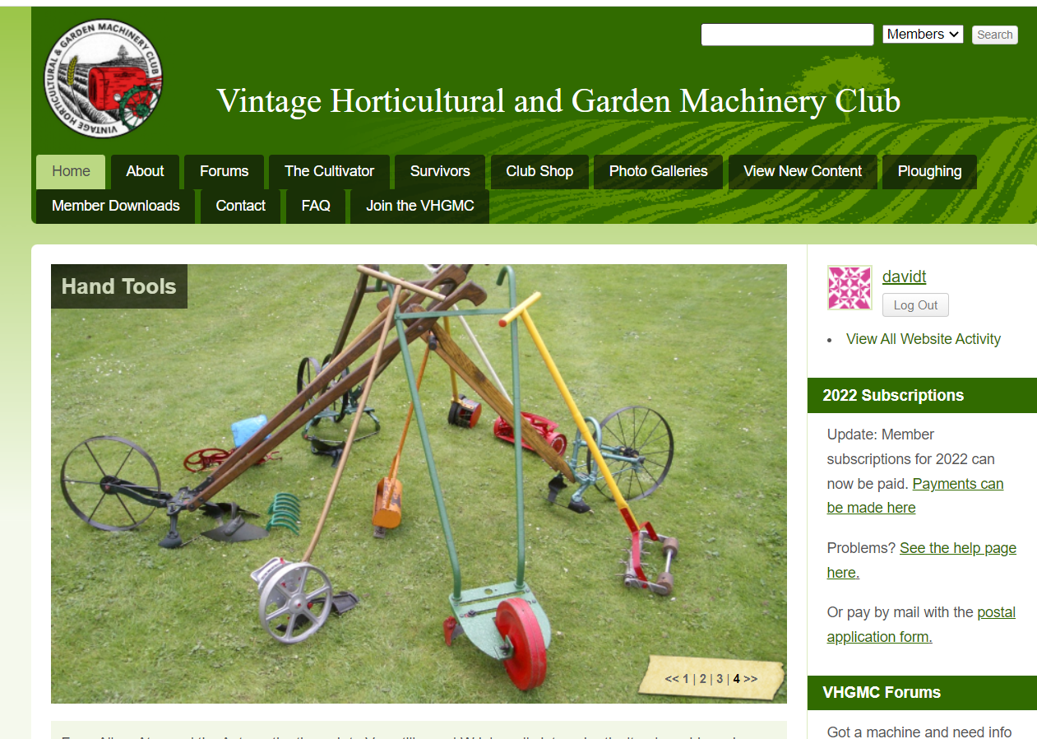
Log in using user name and current password.

Then click on your user name
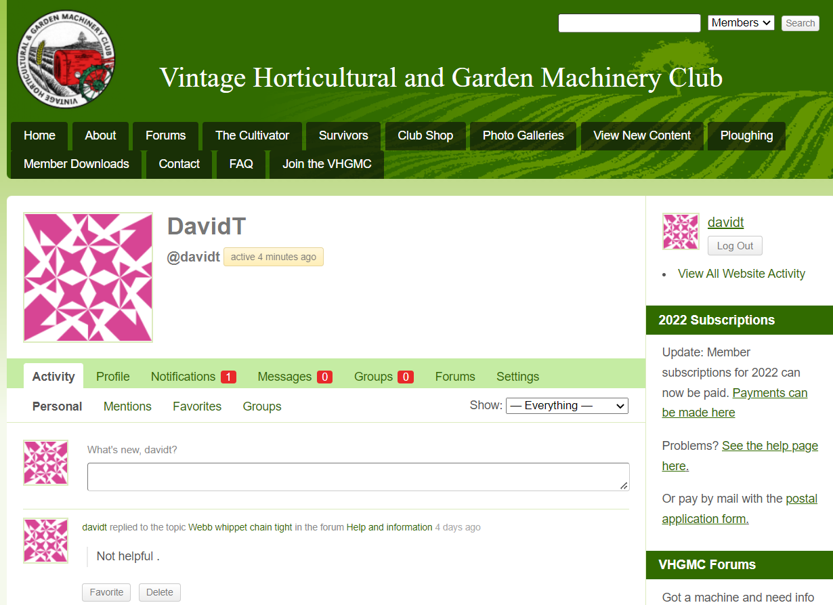
Click on settings
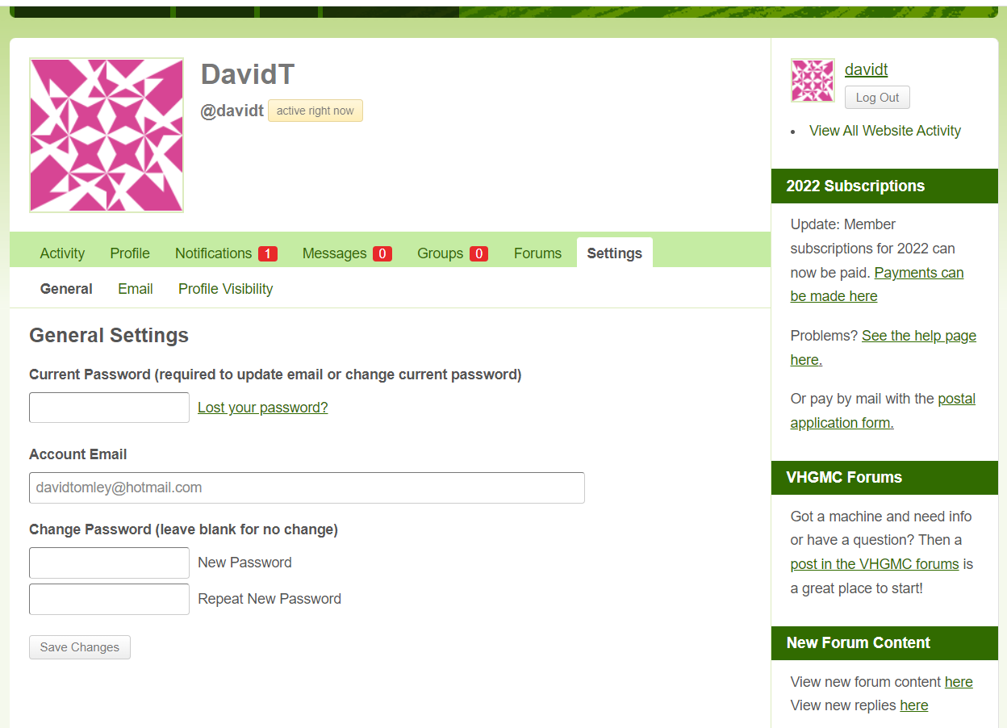
Enter current password

Enter new password and repeat

Save changes

Log out after saving changes.
Next time you log in use the password created in the above.

