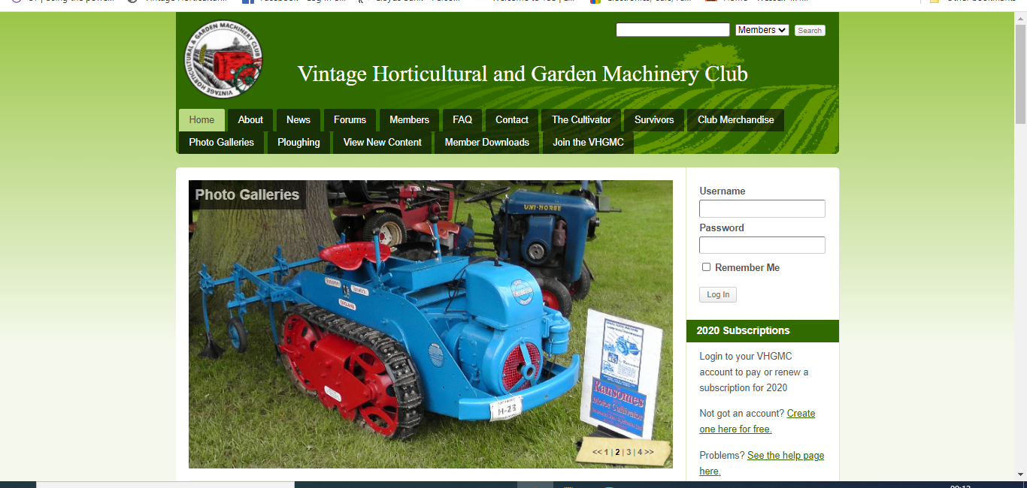
Enter your user name and password and log in
Go to website homepage at www.vhgmc.co.uk You will see this page. Make this the bookmark for VHGMC
This is by far the best way to access the website and forum rather than bookmark forum or any other page.

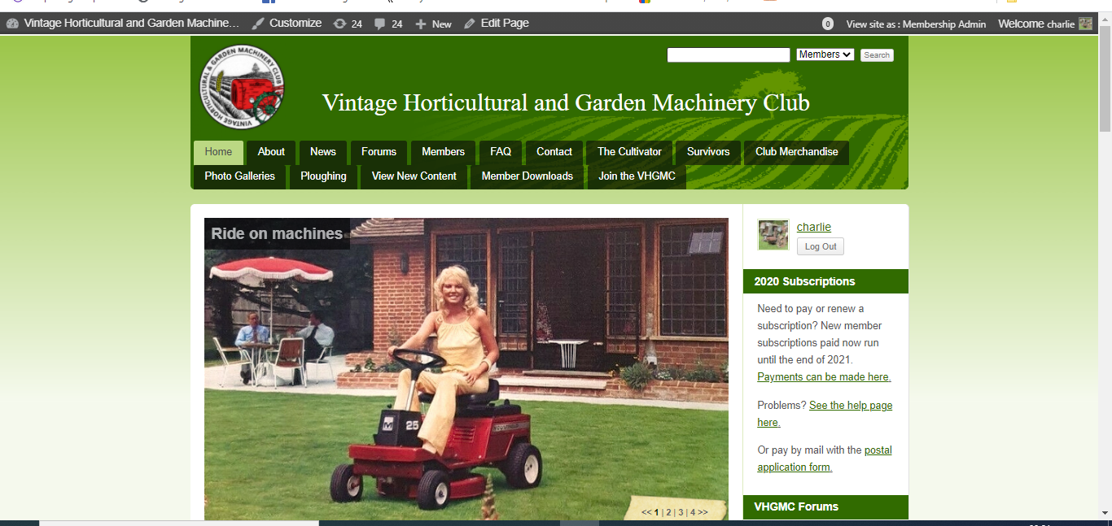
To view all forum topics with recent posts click on ‘View New Content’.

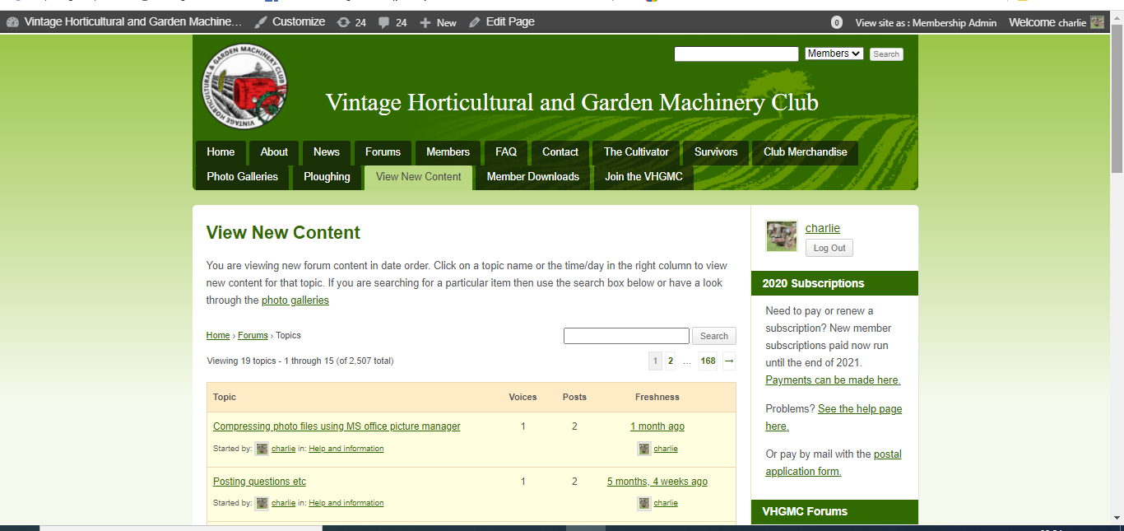
When last comment was posted and who by
Total number of comments posted on topic
Number of users that have posted comment on topic
User that started topic and in which forum section
Topic title
View New Content page.
Scroll down to see more topics.

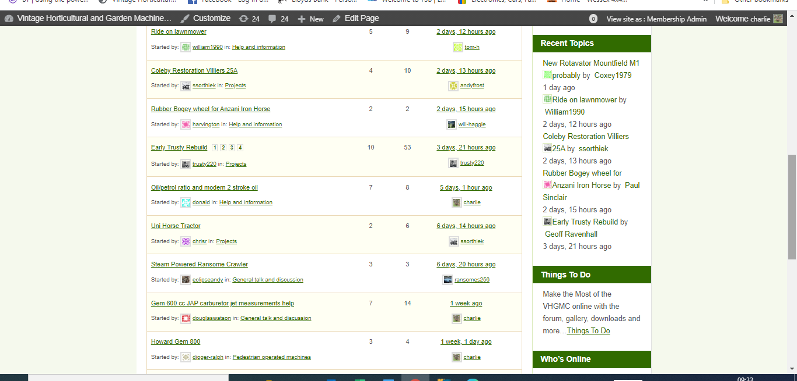
When you have scrolled down the View New Content page you will find your topic.
Click on it, to open it

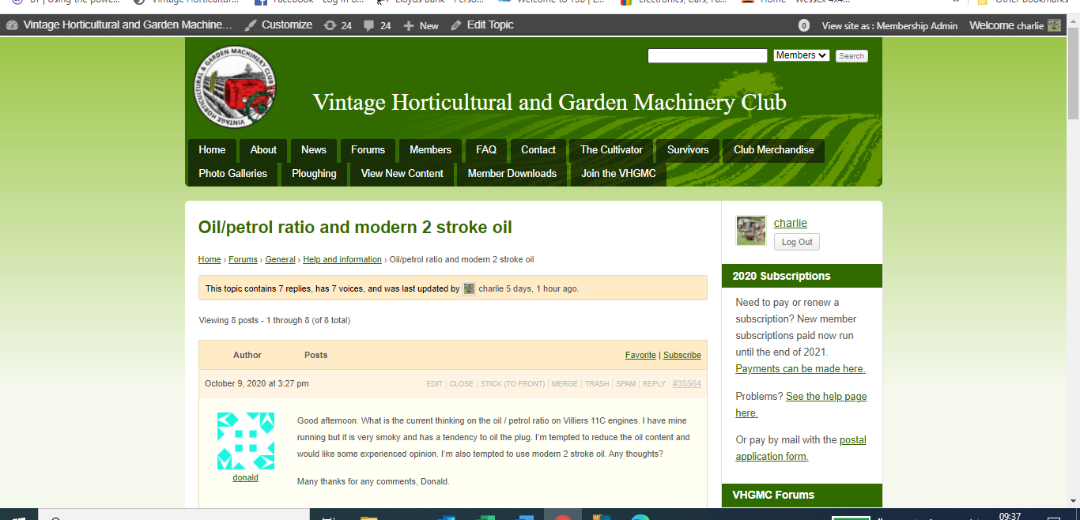

Scroll down page to see most recent comment and text box to add comment
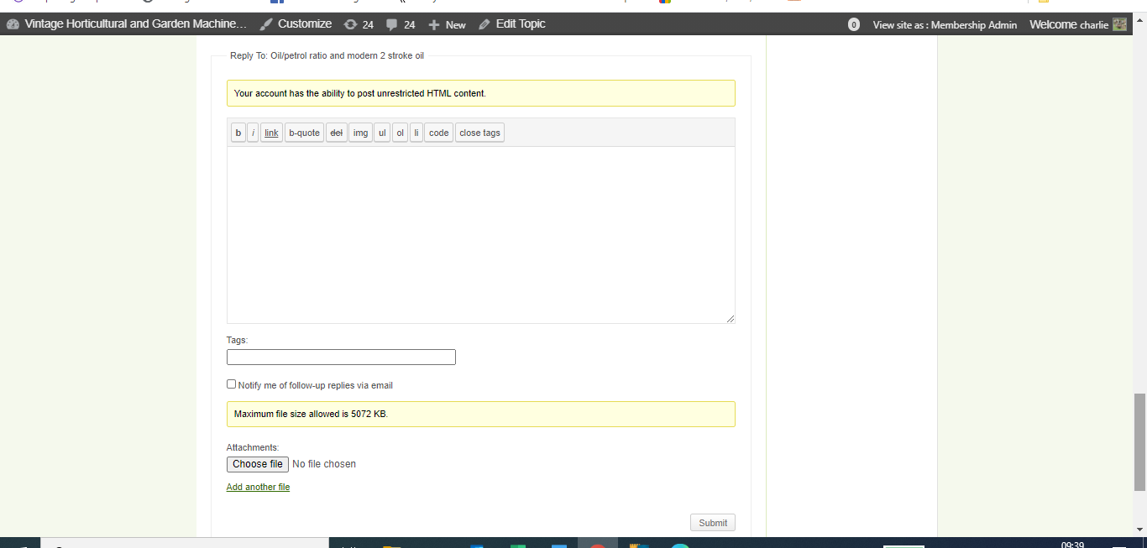
To add photo click on ‘Choose File’ button.
Enter text of your new comment in this box

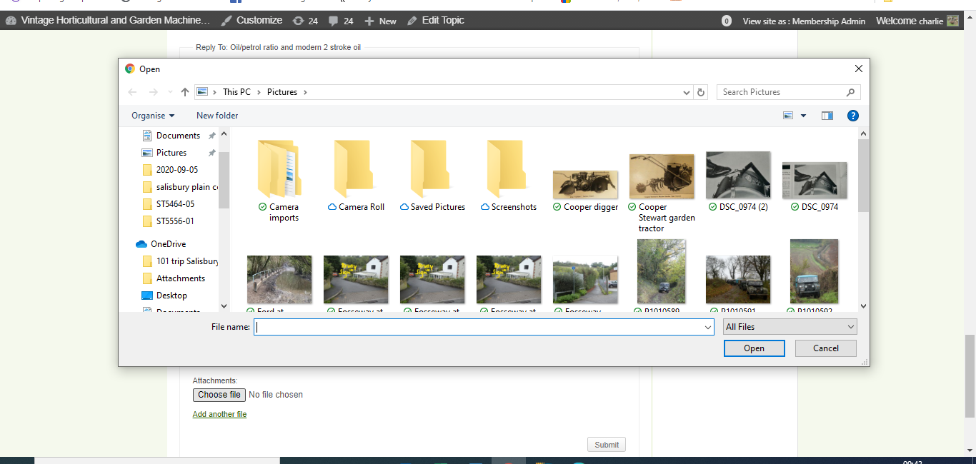
When you click on the ‘Choose File’ button, a new window will open.
In this window navigate to where the photo file you want to add is located and select it, then open. This will add it to your new comment

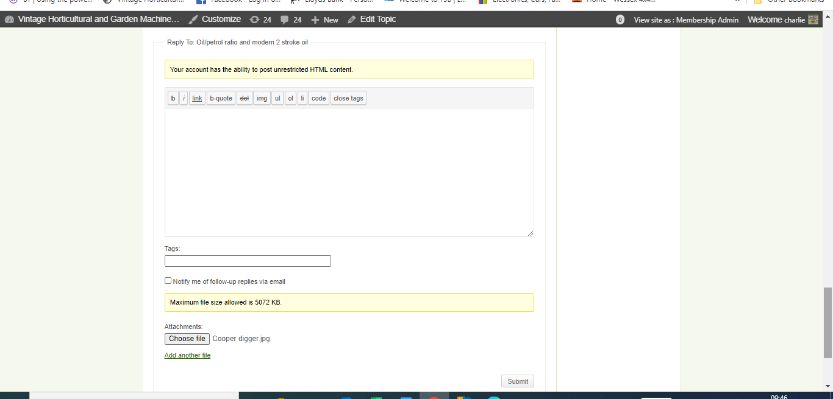
When added photo file name will appear here. Note photo file must not be larger than 5.072Mb. If it is you will need to use photo editing software to compress the file. There is a ‘how to’ guide in the ‘Help and information’ section of forum.
To add another photo, click on ‘Add another file’
When you have finished typing text and adding photos click on ‘Submit’

